What is Ultrasound-Guided Foam Sclerotherapy (UGFS)?

“The Gold Standard of vein disease treatment available to you today at Vein911!”

Surgical vein stripping in an operating room should never be performed because of new technology developed about 15 years ago. Vein stripping surgery used to be limited to those suffering only the most advanced vein disease and the surgery resulted in weeks of recovery and discomfort and, worst of all, more than 60 percent of patients developed a recurrence of their varicose veins.

Thermal Ablation

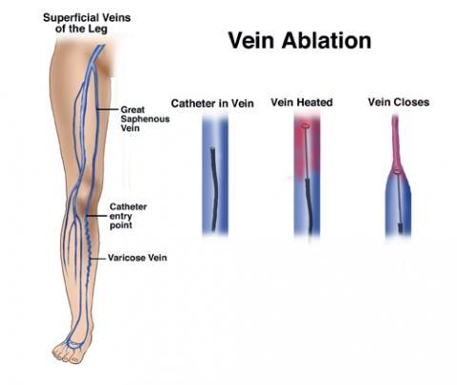
Vein treatment was revolutionized around the year 2000 with the development of thermal ablation. Thermal ablation is the elimination of abnormal, straight veins inside the leg using a straight laser fiber or radiofrequency electrode, elegantly closing the abnormal vein and improving venous circulation in the leg. Almost every patient who is treated for lifestyle-limiting vein symptoms receives thermal ablation these days; however, thermal ablation can only eliminate an abnormal straight vein. Virtually every patient needs an additional procedure to properly treat invisible branch veins coming off the treated straight vein. These branch veins, hidden under the skin, ultimately feed into varicose veins hidden under the skin, as well as visible varicose veins that bulge the skin. There are only two other methods to treat veins: 1) phlebectomy, which only removes visible, bulging veins; and 2) ultrasound-guided foam sclerotherapy (UGFS), which is the only vein treatment that can eliminate all abnormal veins: straight veins, branch veins, and both invisible and visible varicose veins.

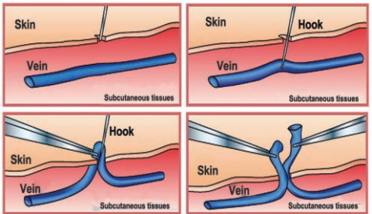
Phlebectomy

In-office surgery of visible varicose veins is pleasantly termed "microphlebectomy" or "ambulatory phlebectomy" but it is, in fact, surgery. Small skin incisions are made in the skin and a small metal hook is used to pull visible varicose veins out. Removing varicose veins with phlebectomy is like removing the "tip of the iceberg," leaving most of your problem veins hiding under the skin. Worse than that, phlebectomy simply does not remove branch veins and varicose veins that can only be seen with an ultrasound machine. Hidden branch veins and varicose veins that are beyond the reach of thermal ablation and phlebectomy enlarge over time, may eventually bulge the skin again, and worse, a patient’s lifestyle-limiting symptoms that initially improved come back all over again. Phlebectomy may result in scarring, bleeding, hematoma, infection, nerve injury with numbness, and lymphatic disruption with possible lymphocele (small fluid collection), lymphedema (swelling) and lymphorrhea (seeping of fluid through puncture site).

Ultrasound Guided Foam Sclerotherapy (UGFS)

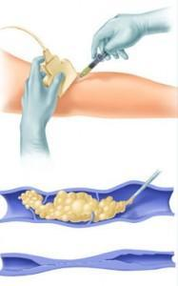
Vein911 performs UGFS after RF ablation and never phlebectomy. UGFS can eliminate all abnormal veins and was refined about 30 years ago. UGFS uses ultrasound to identify hidden, abnormal veins and a tiny needle is directed into the abnormal veins and special foam is injected instantly destroying the abnormal vein. Foam is absorbed by your blood in a few seconds and nothing is left behind. Your body absorbs the treated vein over several months. No surgical incision is made with UGFS and all abnormal veins can be treated. One in 4 new Vein911 patients has recurrent vein problems from prior treatment with thermal ablation and/or phlebectomy. This is because they never received UGFS as part of their vein treatment plan, and hidden abnormal veins were left behind. Dr. John Bergan is widely regarded as the father of vein care in the USA. Around the year 2000, he described the effectiveness and success of UGFS treatment to physicians. UGFS has since gained worldwide popularity but is not commonly used. Quoting from one of Dr. Bergan’s many authoritative textbooks on vein care, Foam Sclerotherapy: A Textbook, “The advent of foam sclerotherapy has been one of the most important developments in the field of phlebology. Just as surgery has evolved into more minimal invasion, so has the treatment of varicose veins. Foam sclerotherapy is quick, efficient, easy to use and inexpensive, and is widely believed to become the dominant form of therapy for varicose veins.”

Ultrasound has revolutionized vein care by localizing vein problems under the surface of the skin and allowing targeted treatment without open surgery or skin incisions. Make sure your vein doctor is an ultrasound expert. Minimally-invasive vascular procedures define modern health care and these minimally-invasive procedures were developed by interventional radiologists. Surgeons have adopted these techniques but many still use surgical procedures and are not comfortable using the latest non-surgical techniques. There is no role for surgery in vein care! Modern vein treatment is not a surgical disease, and seeing a surgeon or “vascular” surgeon is no guarantee you will receive state-of-the-art vein care. In fact, modern vein treatments were pioneered by non-surgeons. Want to get rid of all your varicose veins without surgery? Make sure your vein care practitioner is an UGFS expert. Questions or referrals, please call us at 855-834-6911.

Abridged from What’s the Best Way to Treat My Varicose Veins? by Chris Pittman, M.D., FAVLS, FACR, Posted by Florida Blue on April 4, 2016

